Hesters Théophile

Compte Rendu Tp N°1

Ex 2
<!DOCTYPE html>
<html>
<head>
<meta charset="UTF-8">

</head>
<body>
<div></div>
<style>
.center {
text-align: center;
}
#timings_demo {
position: relative;
width: 530px;
height: 530px;
margin: 0 auto 10px;
border: 1px #aaa solid;
padding: 10px;
}
.test_box {
font-size: 12px;
position: relative;
width: 60px;
height: 60px;
margin-bottom: 10px;
background-color: #eee;
}
.test_box p {
text-align:center;
padding-top:4px;
}

#ease.test_box {
transition: all 4s ease;
border: 1px #f00 solid;
}
#ease-in.test_box {
transition: all 4s ease-in;
border: 1px #0f0 solid;
}
#ease-out.test_box {
transition: all 4s ease-out;
border: 1px #00f solid;
}
#ease-in-out.test_box {
transition: all 4s ease-in-out;
border: 1px #ff0 solid;
}
#linear.test_box {
transition: all 4s linear;
border: 1px #f0f solid;
}
#custom.test_box {
transition: all 4s cubic-bezier(1.000, 0.835, 0.000, 0.945);
border: 1px #0ff solid;
}
#negative.test_box {
transition: all 4s cubic-bezier(1.000, -0.530, 0.405, 1.425);
border: 1px #000 dotted;
}
#timings_demo:hover .test_box, #timings_demo.hover_effect .test_box {
border-radius:30px;
transform: rotate(720deg);
margin-left:420px;
background-color:#fff;
}
</style>
</section>
<section id="differentTiming">
<h2>Different timing functions</h2>
<div id="timings_demo" class="shadow hover">
<div id="ease" class="test_box"><p>Ease</p></div>
<div id="ease-in" class="test_box"><p>Ease<br />In</p></div>
<div id="ease-out" class="test_box"><p>Ease<br />Out</p></div>
<div id="ease-in-out" class="test_box"><p>Ease<br />In Out</p></div>
<div id="linear" class="test_box"><p>Linear</p></div>
<div id="custom" class="test_box"><p>Custom</p></div>
<div id="negative" class="test_box"><p>Awesome!</p></div>
<p class="center"> Hover on me</p>
</div>
</section>
</div>
</body>
</html>
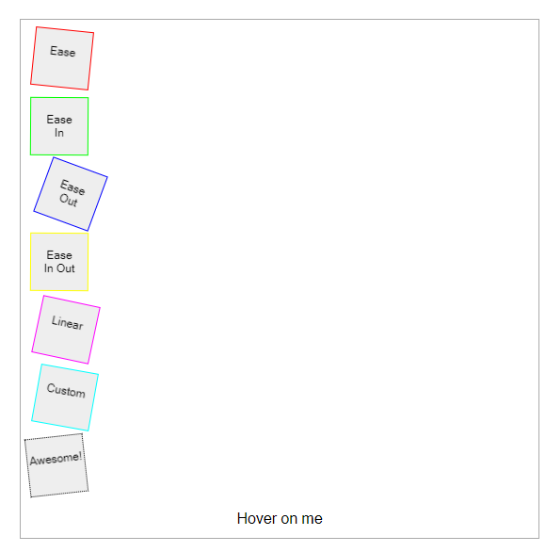
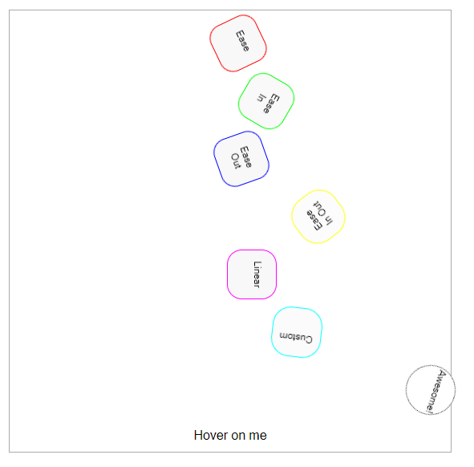

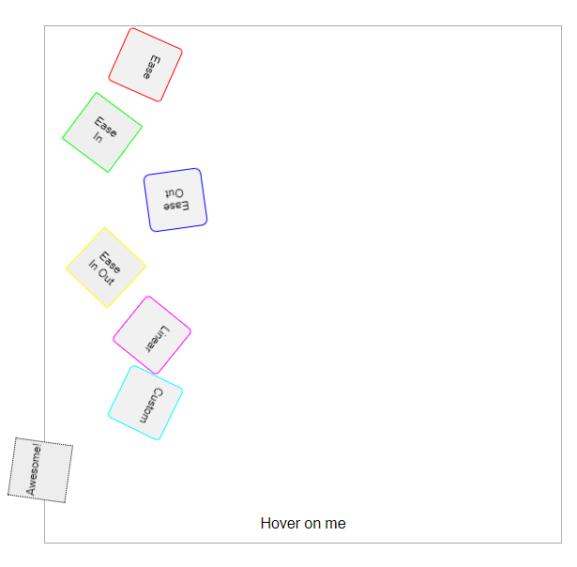

Exo 2.1 :

<!DOCTYPE html>
<html>
<head>
<meta charset="UTF-8">
<style>
div {
width: 100px;
height: 100px;
background: red;
transition: all 4000ms cubic-bezier(0.000, 1.650, 1.000, -0.600);
}
div:hover {

width: 300px;
height: 300px;
}
</style>
</head>
<body>
<div></div>
<p>Survoler le carré rouge ci-dessus pour voir l'effet de la transition.</p>
</body>
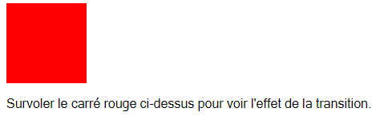

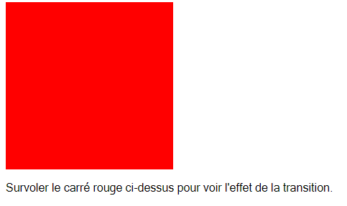

Exo 2.1.2

<!DOCTYPE html>
<html>
<head>
<meta charset="UTF-8">

</head>
<body>
<div></div>
<style>
#delay_demo {
position:relative;
width:500px;
height:400px;
margin:0 auto 10px;
border:1px #aaa solid;
padding:10px;
}
#dd_main {
width:100px;
height:100px;
position:absolute;
top:160px;
left:210px;
background-color:red;
border-radius:50px;
transition: all 2s ease-in-out;}
#delay_demo .center {
width:500px;
position:absolute;
bottom:20px;
}
#dd1, #dd2, #dd3, #dd4, #dd5, #dd6, #dd7, #dd8 {
width:20px;
height:20px;
border-radius:10px;
position:absolute;
top:200px;
left:250px;
background-color:blue;
transition: all 2s ease-in-out; /* Ensures that the element is being transformed in the 3d context so that hw acceleration kicks in where appropriate. */
transform: translate3d(0,0,0);}
#dd1 {
transition-delay: 0.1s; }
#dd2 {
transition-delay: 0.2s; }
#dd3 {
transition-delay: 0.3s; }
#dd4 {
transition-delay: 0.4s; }
#dd5 {
transition-delay: 0.5s; }
#dd6 {
transition-delay: 0.6s; }
#dd7 {
transition-delay: 0.7s; }
#dd8 {
transition-delay: 0.8s; }
#delay_demo:hover #dd_main {
opacity:0;
}
#delay_demo:hover #dd1, #delay_demo.hover_effect #dd1 {
transform: translate(-250px,-200px);}
#delay_demo:hover #dd2, #delay_demo.hover_effect #dd2 {
transform: translate(0,-200px);}
#delay_demo:hover #dd3, #delay_demo.hover_effect #dd3 {
transform: translate(250px,-200px);}
#delay_demo:hover #dd4, #delay_demo.hover_effect #dd4 {
transform: translate(250px, 0);}
#delay_demo:hover #dd5, #delay_demo.hover_effect #dd5 {
transform: translate(250px,200px);}
#delay_demo:hover #dd6, #delay_demo.hover_effect #dd6 {
transform: translate(0,200px);}
#delay_demo:hover #dd7, #delay_demo.hover_effect #dd7 {
transform: translate(-250px,200px);}
#delay_demo:hover #dd8, #delay_demo.hover_effect #dd8 {
transform: translate(-250px,0);}
</style>
<div id="delay_demo" class="shadow hover">
<div id="dd_main"></div>
<div id="dd1"></div>
<div id="dd2"></div>
<div id="dd3"></div>
<div id="dd4"></div>
<div id="dd5"></div>
<div id="dd6"></div>
<div id="dd7"></div>
<div id="dd8"></div>
<p class="center"> Hover on me</p>
</div>
</section>
</div>
</body>
</html>

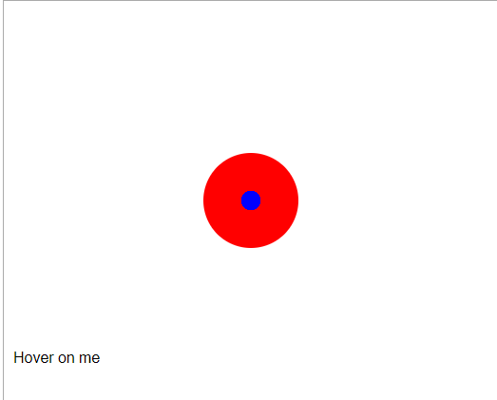
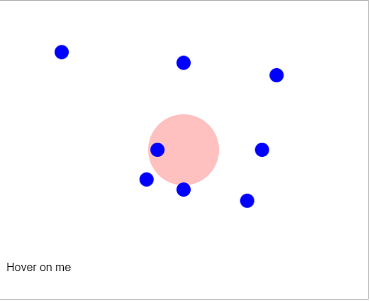
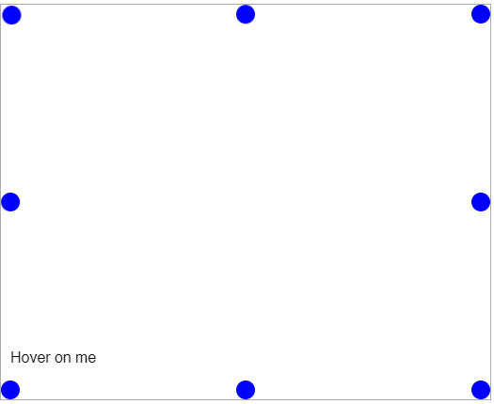

2.1.3
<!DOCTYPE html>
<html>
<head>
<meta charset="UTF-8">

</head>
<body>
<div></div>
<style>
#delay_demo2 {
position:relative;
width:500px;
height:400px;
margin:0 auto 10px;
border:1px #aaa solid;
padding:10px;
}
#delay_demo2 div {
width:100px;
height:100px;
position:absolute;
top:160px;
left:210px;
border-radius:50px;
text-align:center;
}
#delay_demo2 div p {
line-height:70px;
color:white;
font-weight:bold;
}
#dd_main2 {
z-index:10;
background-color:blue;
transition: all 1s ease-in-out;}
#dd_main2a {
z-index:9;
background-color:green;
transition-property: top, left;
transition-duration: 1s, 1s;
transition-delay: 0s, 1s;}
#dd_main2b {
z-index:8;
background-color:red;
transition-property: top, left, border-radius, background-color;
transition-duration: 2s, 1s, 0.5s, 0.5s;
transition-delay: 0s, 0.5s, 1s, 1.5s;}
#delay_demo2 .center {
width:500px;
position:absolute;
bottom:20px;
}
#delay_demo2:hover #dd_main2, #delay_demo2.hover_effect #dd_main2 {
top:0px;
left:0px;
}
#delay_demo2:hover #dd_main2a, #delay_demo2.hover_effect #dd_main2a {
top:320px;
left:420px;
}
#delay_demo2:hover #dd_main2b, #delay_demo2.hover_effect #dd_main2b {
top:0px;
left:420px;
border-radius: 0;
background-color:orange;
}
</style>
<div id="delay_demo2" class="shadow hover">
<div id="dd_main2"><p>Normal</p></div>
<div id="dd_main2a"><p>Example 1</p></div>
<div id="dd_main2b"><p>Example 2</p></div>
<p class="center"> Hover on me</p>
</div>
</section>
</section>
</div>
</body>
</html>

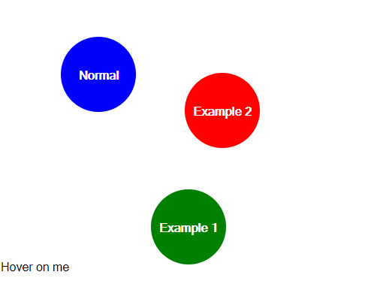
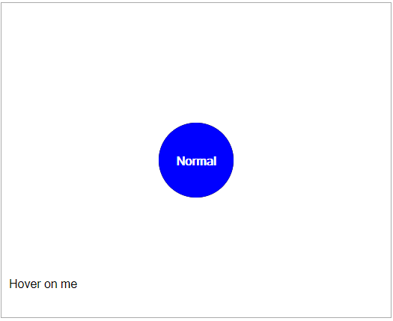
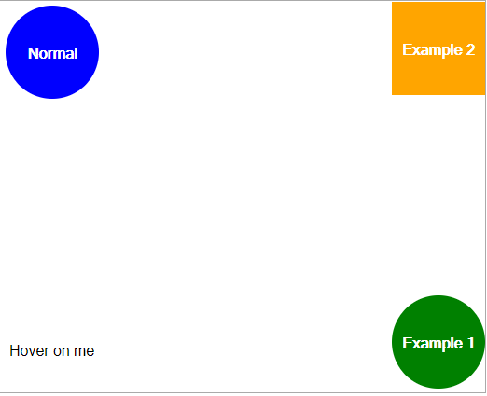

Ex 3.1

<!DOCTYPE html>
<html>
<head>
<meta charset="UTF-8">
<style>
@keyframes resize
{0% {padding: 0;
}
50%
{
padding: 0 20px;
background-color:rgba(255,0,0,0.2);
}
100%
{
padding: 0 100px;
background-color:rgba(255,0,0,0.9);
}
}
#box {height:50px;width:50px;
margin:0 auto;
border:1px red solid;
background-color:rgba(255,0,0,0.7);
}#box:hover {animation-name:resize;
animation-duration: 1s;
animation-iteration-count: 4;
animation-direction: alternate;
}
@keyframes demo

{
from
{
animation-timing-function: ease;
transform: translateX(0px);
}
50%
{
animation-timing-function: ease-in;
transform: translateX(300px);
}
to
{
animation-timing-function: ease-inout;
transform: translateX(900px);
}
}
#testCanvas
{ animation-delay: 0s; animation-duration: 6s;
animation-iteration-count: infinite;
animation-name: demo;
}
</style>
</head>
<body>
<div id="box"></div>
</body>
</html>
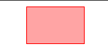


Ex 3.2

<!DOCTYPE html>
<html>
<head>
<meta charset="UTF-8">
<style>
#animated_div {
margin-top: 50px;
width:70px;
height:47px;
background: #92B901;
color: #ffffff;
position: relative;
font-weight:bold;
font-size:20px;
padding:10px;
animation:animated_div 5s 1;
border-radius:5px;
}

@keyframes animated_div
{
0% {transform: rotate(0deg);left:0px;}
25% {transform: rotate(20deg);left:0px;}
50% {transform: rotate(0deg);left:500px;}
55% {transform: rotate(0deg);left:500px;}
70% {transform: rotate(0deg);left:500px;background:#1ec7e6;}
100% {transform: rotate(-360deg);left:0px;}
}

</style>
</head>
<body>
<div id="animated_div">Ex 3.3 demo 2</div>
</body>
</html>


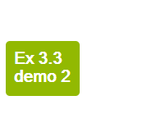

Ex 4.1

<!DOCTYPE html>
<html>
<head>
<style>
.div1 {
border-radius: 25px;
background: #73AD21;
padding: 20px;
width: 200px;
}
.div2 {
margin-top: 10px;
border-bottom-left-radius: 25px;
background: #73AD21;
padding: 20px;
width: 200px;
}

</style>
</head>
<body>

<div class="div1">This is a div element. It has some text.</div>
<div class="div2">This is a div element. It has some text.</div>

</body>
</html>
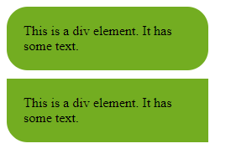

Ex 4.2

<!DOCTYPE html>
<html>
<head>
<style>
.div1 {
border: 10px solid transparent;
border-image: url(border.png) 30 round;
}

.div2 {
border: 10px solid transparent;
border-image: url(border.png) 30 stretch;
}
</style>
</head>
<body>

<div class="div1">This is a div element. It has some text.</div>
<div class="div2">This is a div element. It has some text.</div>

</body>
</html>

Ex 4.3

<!DOCTYPE html>
<html>
<head>
<style>
body {
background-image: url(img_flwr.gif), url(paper.gif);
}
body {
background:url(img_flwr.gif);
background-size: 100px 80px;
background-repeat: no-repeat;
}
html {
background: url(img_flower.jpg) no-repeat center center fixed;
background-size: cover;
}
div {
border: 10px solid black;
padding: 35px;
background: url(img_flwr.gif);
background-repeat: no-repeat;
background-origin: content-box;
}
div {
border: 10px dotted black;
padding: 35px;
background: lightblue;
background-clip: padding-box;
}
</style>
</head>
<body>

<h1>This is a Heading</h1>
<p>This is a paragraph.</p>
<p>This is another paragraph.</p>

</body>
</html>

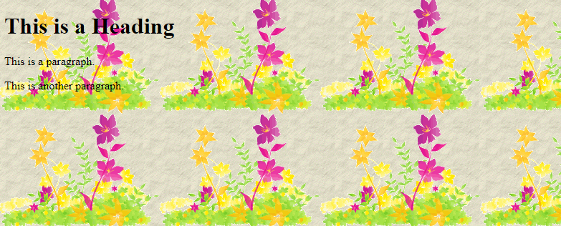
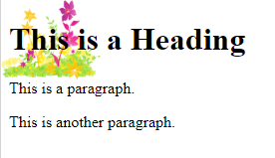
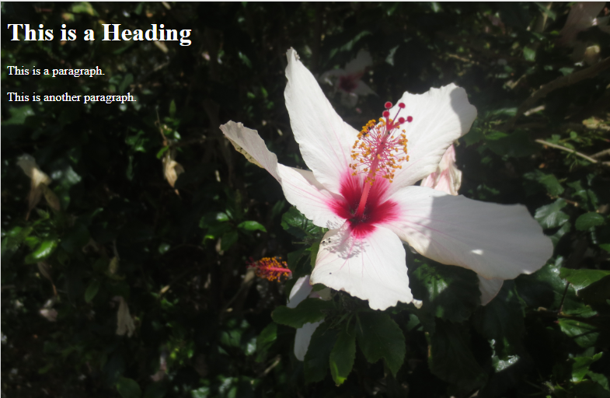

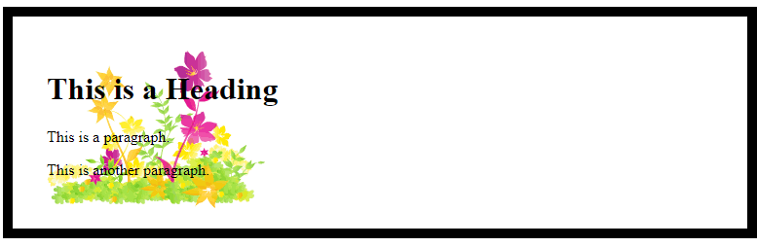

Ex 4.4

<!DOCTYPE html>
<html>
<head>
<style>
.div1 {
background-image: linear-gradient(white, green);
}
.div2 {
background-image: linear-gradient(to bottom right, white, green);
}
.div3 {
background-image: linear-gradient(70deg, white, green);
}

.h11 {
background-color: rgba(0,255,0,0.3);
}
.h12 {
background-color: hsl(0,100%,50%);
}
.h13 {
background-color: hsla(0,100%,50%,0.3);
}
.h14 {
text-shadow: 2px 2px;
}
.h15 {
text-shadow: 2px 2px 5px green;
}
.h16 {
text-shadow: 2px 2px 5px green, 0 0 10px red;
}
</style>
</head>
<body>

<div class="div1" style="height:200px"></div>
<div class="div2" style="height:200px"></div>
<div class="div3" style="height:200px"></div>

<h1 class="h11">This is a Heading</h1>
<h1 class="h12">This is a Heading</h1>
<h1 class="h13">This is a Heading</h1>
<h1 class="h14">This is a Heading</h1>
<h1 class="h15">This is a Heading</h1>
<h1 class="h16">This is a Heading</h1>
<p>This is a paragraph.</p>
<p>This is another paragraph.</p>

</body>
</html>

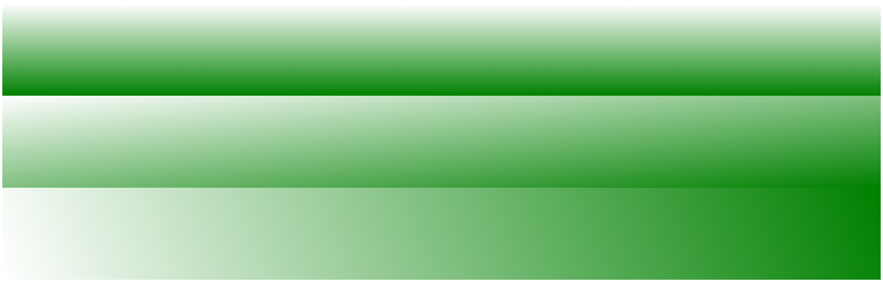
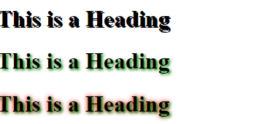

Ex 4.5
<!DOCTYPE html>
<html>
<head>
<style>
.div1 {
width: 100px;
height: 100px;
background-color: lightblue;
border: 1px solid black;
transform: translate(100px,200px);
}
.div2 {
width: 100px;
height: 100px;
margin: 50px;
background-color: lightblue;
border: 1px solid black;
transform: rotate(45deg);
}
.div3
{
width: 100px;
height: 100px;
margin: 50px;
background-color: lightblue;
border: 1px solid black;
transform: scale(0.5,2);
}
</style>
</head>
<body>

<div class="div1"></div>
<!--<div class="div2"></div>
<div class="div3"></div>
-->

</body>
</html>

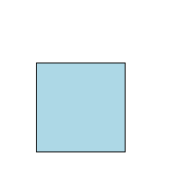
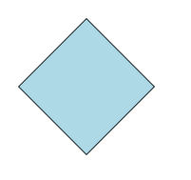
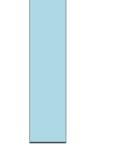

Ex 4.6
<!DOCTYPE html>
<html>
<head>
<style>
.div1 {
width: 100px;
height: 100px;
background-color: lightblue;
border: 1px solid black;
transform: rotateX(150deg);
}

.div2 {
width: 100px;
height: 100px;
background-color: lightblue;
border: 1px solid black;
transform: rotateY(120deg);
}
.div3 {
width: 100px;
height: 100px;
background-color: lightblue;
border: 1px solid black;
transform: rotateZ(90deg);
}
</style>
</head>
<body>

<div class="div1">This is a div element</div>
<div class="div2">This is a div element</div>
<div class="div3">This is a div element</div>

</body>
</html>

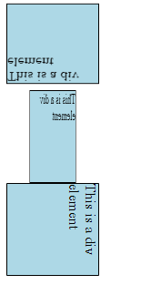

Ex 4.7

<!DOCTYPE html>
<html>
<head>
<style>
.button {
background-color: #4CAF50; /* Green */
border: none;
color: white;
padding: 15px 32px;
text-align: center;
text-decoration: none;
display: inline-block;
font-size: 16px;
}
.button1 {background-color: #4CAF50;} /* Green */
.button2 {background-color: #008CBA;} /* Blue */
.button3 {background-color: #f44336;} /* Red */
.button4 {background-color: #e7e7e7; color: black;} /* Gray */
.button5 {background-color: #555555;} /* Black */
.button1 {border-radius: 2px;}
.button2 {border-radius: 4px;}
.button3 {border-radius: 8px;}
.button4 {border-radius: 12px;}
.button5 {border-radius: 50%;}
.button1 {padding: 10px 24px;}
.button2 {padding: 12px 28px;}
.button3 {padding: 14px 40px;}
.button4 {padding: 32px 16px;}
.button5 {padding: 16px;}
</style>
</head>
<body>
<button class="button1"> Bouton</button>
<button class="button2"> Bouton</button>
<button class="button3"> Bouton</button>
<button class="button4"> Bouton</button>
<button class="button5"> Bouton</button>
</body>
</html>

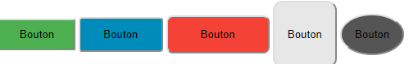

Ex 4.8
<!DOCTYPE html>
<html>
<head>
<style>
.newspaper {
column-count: 5;
column-gap: 50px;
column-rule: 1px solid lightblue;
column-rule-style: solid;
}

h2 {

column-span: all;
}
</style>
</head>
<body>

<div class="newspaper">
<h2>TP CSS Colonnes</h2>
Lorem ipsum dolor sit amet, consectetuer adipiscing elit, sed diam nonummy nibh euismod tincidunt ut laoreet dolore magna aliquam erat volutpat. Ut wisi enim ad minim veniam, quis nostrud exerci tation ullamcorper suscipit lobortis nisl ut aliquip ex ea commodo consequat. Duis autem vel eum iriure dolor in hendrerit in vulputate velit esse molestie consequat, vel illum dolore eu feugiat nulla facilisis at vero eros et accumsan et iusto odio dignissim qui blandit praesent luptatum zzril delenit augue duis dolore te feugait nulla facilisi. Nam liber tempor cum soluta nobis eleifend option congue nihil imperdiet doming id quod mazim placerat facer possim assum.
</div>

</body>
</html>

